NIC Automation & Installation Guide

Revision History
Date | Version | Description | Author | Approved/Reviewed By | Status
11 January, 2011 | 1.0 | Automation Installation Guide | Gaurav Parrikar | Omkar Prabhu | Approved
1March 2011 | 1.0 | Updated based on feedback from team | Gaurav Parrikar | Omkar Prabhu | Approved

Table of Contents

1 Introduction 3

2 Automation Setup 3

3 Installation 4

3.1 Ruby Installation 4

3.2 Watir-Webdriver Installation 4

3.3 RSpec Installation 4

3.4 fastercsv Installation 4

3.5 Win32-Clipboard 4

4 Prerequisites before running the scripts 4

4.1 Installing Firefox; Creating a Profile 4

4.2 Browser Settings 7

4.3 Installing RCE 7

4.4 Additional Configuration settings for Mozilla 8

4.5 Handling File Download in Mozilla Firefox 9

5 Running Automation 10

5.1 Folder Structure 10

5.1.1 Further extension 11

5.2 Setup & Configuration 11

5.2.1 Script configuration 11

5.2.2 Mail configuration 12

5.2.3 Test case data configuration 13

5.3 Running Scripts 13

5.3.1 One click without mail 13

5.3.2 One click with mail 13

5.3.3 In Rspec 13

5.4 Link checker 14

6 Clean up post Automation tests 14

Introduction

The NIC test Automation is done using watir webdriver, which is also known as Selenium-2. This document covers the steps involved in setting up Selenium and running the tests by making use of RSpec.

Automation Setup

The flowchart below shows the sequential steps that need to be performed to complete the setup and get the scripts running for NIC Automation.

Download Ruby 1.8.7

Install Watir WebDriver gem

Install rspec

Install fastercsv gem

Install RCE (add-on for Firefox)

Change the default download folder for the Firefox profile

About:config settings for Firefox profile

Run tests using RSPEC

Install Firefox; Create a Firefox Profile

We have tested and verified this in Firefox version 3.6 however other browsers can also be used

Installation

The installation includes a stepwise procedure which involves installing ruby and some gems.

Ruby Installation

It is generally recommended to use Ruby 1.8.7 for running both Watir and Selenium. The one click installer for ruby can be downloaded from http://rubyforge.org/frs/?group_id=167. Complete the installation process.

Please ensure that ruby path is set in Environment Variables so that ruby programs run directly

Watir-Webdriver Installation

Watir-webdriver is a gem that can be installed once the ruby installation is complete. Run the command “gem install watir-webdriver” to install Watir-Webdriver. In case there are any errors that are reported saying the command is invalid, please ensure that the path for the bin folder is correctly specified in the Environment Variable.

RSpec Installation
RSpec is mainly used when doing Test-Driven Development by the Ruby programmers. In the current automation it is used for report generation. RSpec can be installed by using the “gem install rspec” command from the command line

fastercsv Installation

Fastercsv is a gem that is needed to be installed to ensure that we can read through the excel files without needing to have Microsoft office installed on the particular machines. In some of the scripts, we download the csv files and need to read them. This is done by using fastercsv. Fastercsv can be installed by using the “gem install fastercsv” command from the command line.

Win32-Clipboard

Please type command “gem install win32-clipboard”

Prerequisites before running the scripts

Before we are actually start executing the scripts, there are a few prerequisites that need to be fulfilled on a machine.

Installing Firefox; Creating a Profile

This setup has been tried by team by using Firefox and version 3.6. Team can create its own setup using any other browser too and it will work as expected

Install Firefox version 3.6 http://www.mozilla.org/en-US/firefox/all-older.html

While using Selenium, each time a new profile is created for the execution. However in our case, the network site can be a secure site and in the case we access the site using a new profile, we will get the certificate exception each time. Hence we create a profile and add the certificate to it. Creating a profile involves the following steps:

- Run the “firefox.exe -ProfileManager -no-remote” command

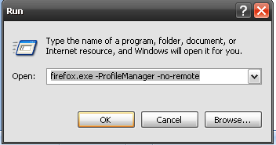

- Select the option to create a new profile

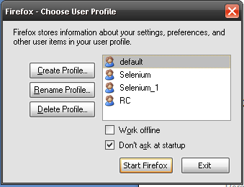

- On the screen that appears, click Next

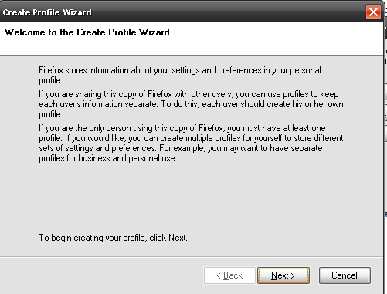

- Enter the name of the profile as “Selenium” in the available text box. We have made use of the name Selenium in the scripts for making use of the profile and hence recommend using the same to avoid any changes than may be needed in the scripts.

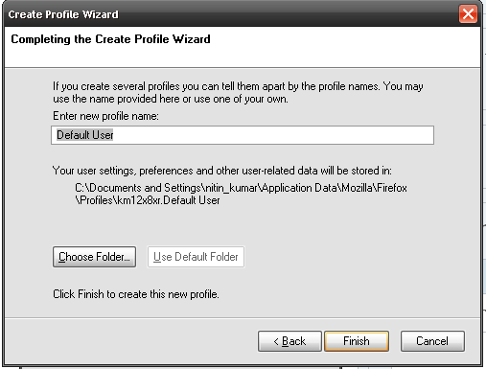

- Choose the folder where you want to save the profile and click Finish

Browser Settings

There are a few settings that need to be made to the browser, for the created profile. The profile can be started by selecting the profile and clicking on the Start Firefox button.

Installing RCE

Install the add-on “Remember Certificate Exception” for Mozilla. This is used to store the entry for the certificate. This is needed because Selenium creates a new copy of the profile and it needs to remember the certificate for the secure sites. This can be downloaded and added to Mozilla from https://addons.mozilla.org/en-US/firefox/search/?q=Remember%20Certificate%20Exception.

Additional Configuration settings for Mozilla

There are some settings that need to be done for the scripts to execute successfully. When opening a site, it is observed that at times there are some java scripts running. The default time that Firefox allows for these scripts to complete is 10 seconds, which at times is less. We can change the values by using the following steps:

- Open the browser in the created profile
- Enter about:config in the address field

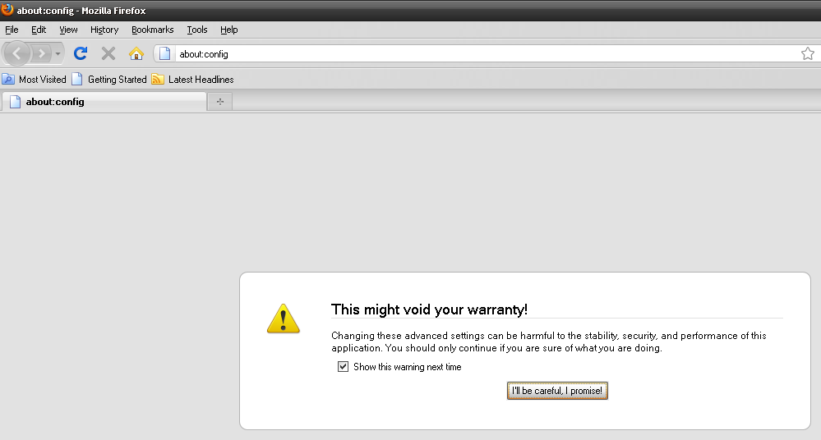

- Click the button I’ll be careful, I promise
- In the search tab, search for “dom.max_script_run_time”. Right click on it and modify the value to 100

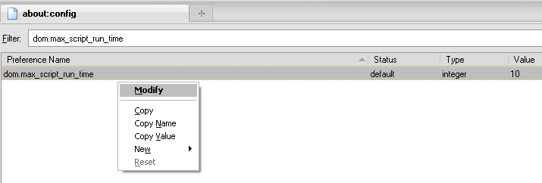

- Similarly as done in step 4, search for “dom.max_chrome_script_run_time” and modify the value to 100

Handling File Download in Mozilla Firefox

Below steps will help in auto saving downloaded files in Firefox/Watir Webdriver without having to click on troublesome ‘Save as’ dialog.
- Create a Firefox profile

Use Run “firefox.exe -ProfileManager -no-remote” command

- Open Firefox in newly created profile

- Click on file to be downloaded.

The ‘Save as’ dialog would pop up. Click on ‘Save File’ radio button and check in ‘Do this automatically for files like this from now on’ check box. Click on ‘OK’ button.

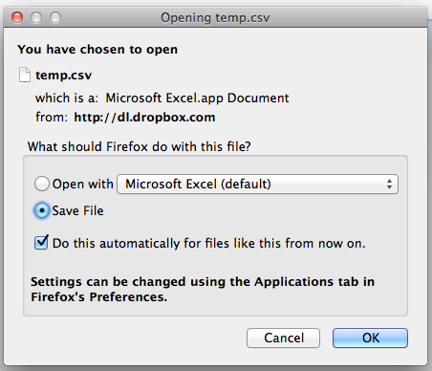

- What this does is it creates an entry in the Applications tab of the settings to always download the files of above type. From now on Firefox will automatically download above type of file without prompting ‘Save as’ dialog.

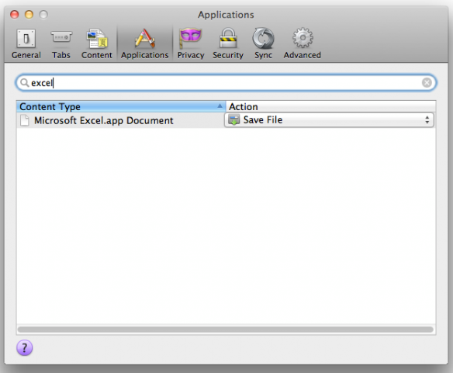
- Now go to Firefox Tools>Options>General and set the default download folder. Please note that this should be the folder where we want our downloaded files to be placed.

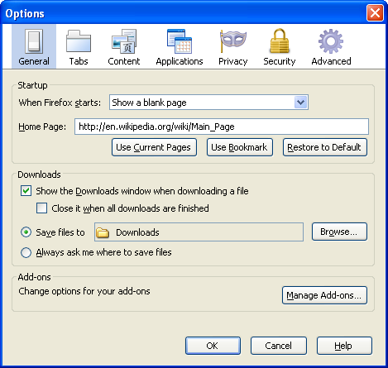

- Now we can use our newly created profile to run Watir Webdriver scripts. Just click on link to download the file and Firefox will automatically download the file and place it in folder we specified.

This Automation can be run on other supported versions of Firefox and also on other browsers. The testing team will be expected to make a slight change in the code to refer to the intended Brower’s

Running Automation

This section gives details of how to configure automation suite.

Folder Structure

We have followed following folder structure

Automation_NIC
- Cases
- Downloads
- InputRepository
- lib
- CONFIG_TEMPLATE.rb
- delete.bat
- test.bat
- mail.rb
- testrun_with_mail.bat
- Setub.rb

Cases -> Contains all the script files

Downloads -> All files downloaded during test runs should be placed here. (Browser setting has to be done for this). Please make sure files are deleted at end of suite run.

InputRepository -> All the input files should be placed in this folder

lib -> Any library functions/ user defined functions should be placed in this folder.

CONFIG_TEMPLATE.rb -> Config template file which could be used to create a config file to used in scripts

delete.bat -> This file deletes the downloaded csv/xls/pdf files placed in Downloads folder

test.bat - > This batch file will invoke the rspec command which will run all cases in Cases folder

mail.rb -> This script invokes test.bat and will send out report file via email to list of recipients

testrun_with_mail.bat -> This batch file invokes the mail.rb file.

Further extension

The extension of the test suite is simple. Just code new test cases and place them in the “Cases” folder the suite will take care of execution

Setup & Configuration

Once installation is complete, just checkout the suite to any drive and run the file ”Setup.rb”. This will create all required files on your machine

Script configuration

All scripts can be easily configured by modifying the “Config.rb” file as it contains all server details and username\passwords. Please point it to the correct addresses for new configurations. Kindly make use of CONFIG_TEMPLATE.rb file to create Config.rb by specifying the desired URLs/credentials.

The “Config.rb” file resides in the InputRepository Folder

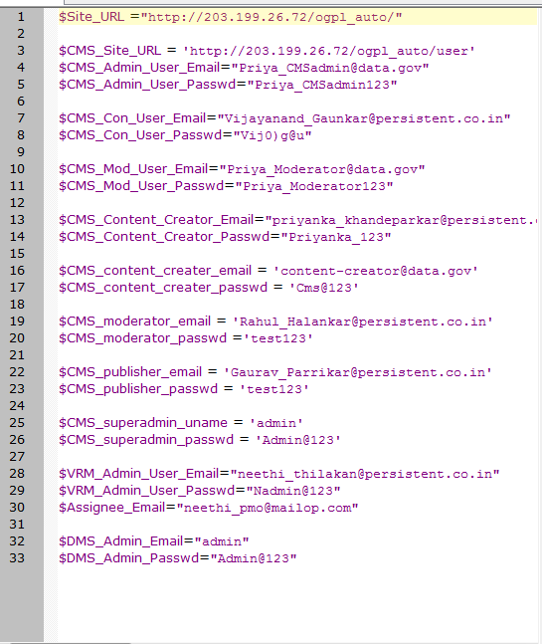

Mail configuration

The suite is one click and upon completion will send a mail to all configured addresses

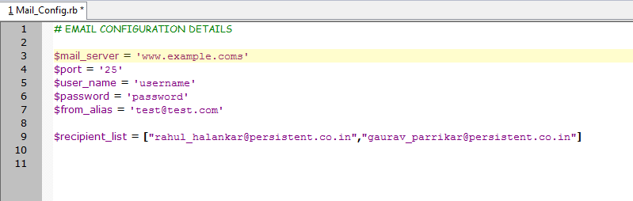

Please enter available SMTP server

Please provide user name/ password

Please provide email addresses (all applicable, in the format shown In above image

The “Mail_Config.rb” file resides in the InputRepository Folder

Test case data configuration

Each test case script refers to its own data and can be configured by makings changes to the files in

Running Scripts

This section described on how to run the suite. Please keep back-up of Database prior to running the automation so that it can be restored back once automation is compete

One click without mail

Please run “testrun.bat” file in the “Automation_NIC” folder. The suite will run all scripts from “Cases” folder. On completion report will be available as “Report.html” in the same folder

One click with mail

Please run “testrun_with_mail.bat” file in the “Automation_NIC” folder. The suite will run all scripts from “Cases” folder. On completion report will be available as “Report.html” in the same folder. Also, an email will be sent to all configured email addresses

In Rspec

The scripts can be run by making use of the “rspec --format h -o Report.html --tag ~datacreation --tag ~temp --tag ~inprogress Cases\*” command. The various options that are used with the rspec command are described below:
- --format: Specifies what format to use for output. There are various options that are available. We make use of the option h which creates an html file with the results.
Built in formats | Functionality
silent or l | No output
progress or p | Text-based progress bar
profile or o | Text-based progress bar with profiling of 10 slowest examples
specdoc or s | Code example doc strings
nested or n | Code example doc strings with nested groups indented
html or h | A nice HTML report
failing_examples or e | Write all failing examples - input for --example
failing_example_groups or g | Write all failing example groups - input for --example

- -o: this is used to specify the name of the output file
- --tag: There is an option of running a particular set of cases, which can be done by tagging the tests. We can either select to run the cases only with a particular tags and also not running the cases that have the tag. In the case we wish to execute the cases which have a tag as test, the command looks like “–-tag test” and for the scenario that we don’t want to run the cases with the tag test, the command looks like “–-tag ~test”.
- The last field comprises of the location of the scripts from the current location. As mentioned in the folder structure, all the scripts are placed in the Cases folder, hence we specify “Cases\*”

Link checker

We can use xenu for link checking. It will recursively scan all pages and detect broken links

http://home.snafu.de/tilman/xenulink.html

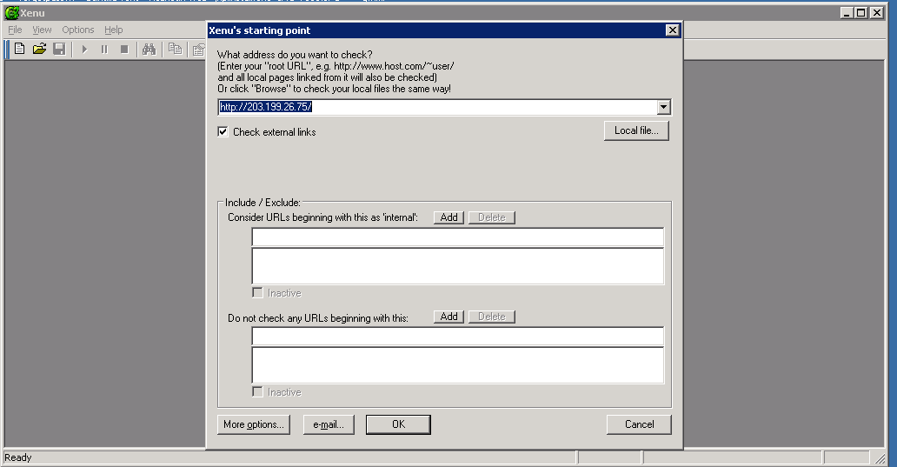

Clean up post Automation tests

Following steps must be performed once automation suite is run daily if required

- Check if any browsers are open on test machine. All browser instances must be closed
- Ensure code sync and a fresh DB insulation has happened correctly. Please run “DB_restore.bat” on completion of automation suite
- Monitor “C:” drive Disk space, if the space is constantly decreasing, delete temp Firefox profiles. Firefox profiles are saved in “C:\Documents and Settings\{user_name}\Local Settings\Temp”

For DB cleanup we can use the “DB_restore.bat” file in automation folder. For any changes in server configuration the shell script it invokes will have to be modified slightly. We use a utility called plink to connect from windows to Linux machine

